ROOM MOPPING ROBOT

WORKSHOP PRACTICES 2019
GROUP-R

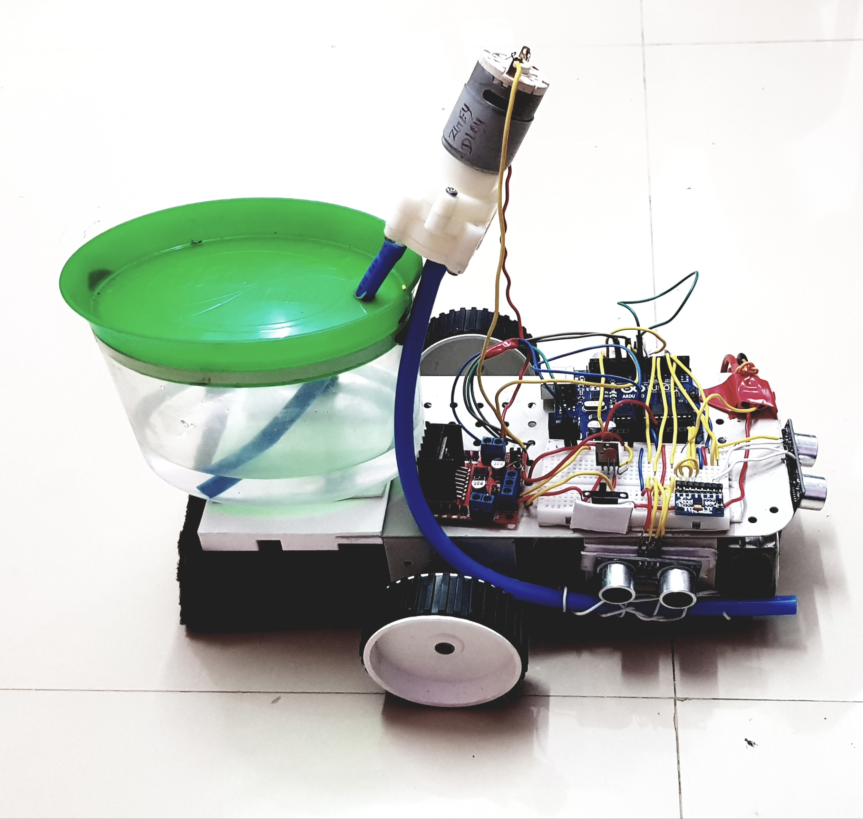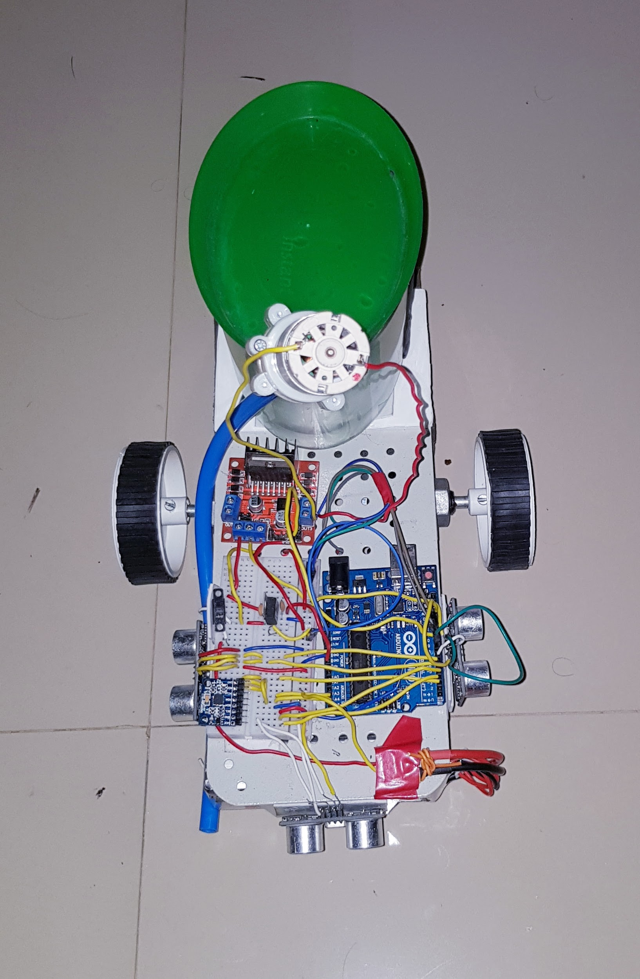

Raswanth Murugan-131801012
Alisetti Sai Vamsi-111801002
Yogesh R-111801047
Madhav Ramesh-121801027
Subhash S-111801042
Shrehari Prsad-131801025
OBJECTIVE:

To clean a rectangular room, using the room mopping robot (Autonomous Room Cleaning Robot). It will automatically clean the entire room once placed at any of its corners.

COMPONENTS USED:

Metallic Chassis (equipped with holes for wiring), Mini Breadboard, 3 Ultrasound Sensors, 1 Arduino-Uno, 2 Motor Drivers (L298N), 1 Li-Po Battery, Plastic Container, 12V DC pump, Pipes (8mm dia), Sponge, 3D printed Sponge Holder, Connecting wires, 2 12V DC motors, MPU-6050, IC-7808.

TOOLS USED:

Soldering Iron, Insulation Tape, Double-sided Tape, Scissors, Screw driver (For motor driver).

PROJECT DESCRIPTION AND SOLUTIONS:

- The robot is first placed at one of the corners of a rectangular room (used for demonstration).
- It will automatically start moving once placed on the floor, and turns when it detects the wall ahead of it. This is done with the help of an ultrasound sensor on the front, as well as an analog gyroscope (MPU-6050).
- The MPU-6050 measures the angle of turning and allows a 180 degree turn (One motor is switched off while the other runs at its full capacity. This is known as a differential turn).
- While the turn is being executed, the Ultrasound sensors are switched off. This ensures that no readings of distance are taken while the robot is taking a turn.
- A plastic container having water is kept on the robot and the 12V DC pump is readily switched on and off (through an IC-7808 and the Arduino, in definite time intervals) to wet the floor to be cleaned by the sponge, which is kept in place by a 3D printed sponge holder and clips.
- The robot moves in straight lines only, implying that it follows a trajectory which is a series of continuous adjacent columns. This is the most efficient way to clean the entire room, not leaving any patches that would otherwise be left dry and uncleaned.
- The Ultrasound sensors on the sides are kept so as to detect the end of the room (the last column to be cleaned by the robot).
- Once the last column is reached, the robot stops as soon as it detects the wall ahead with the help of the sensor in the front.
- The entire robot is powered by a 12V Li-Po battery, placed at the head.
NOTE:
- An Arduino-Uno cannot be used to run the pump or the motors directly (it can only supply 5V). For this reason the Motor Drivers (L298N) are placed between the arduino and the other components which have higher voltage requirements, so that these requirements are met.
- A Voltage Regulator (IC-7808) allows to run the pump at a voltage of 8V, as that is the requirement to achieve the room cleaning.
- Soldering iron was used to solder the connections for the Ultrasound Sensor in place.

DIFFICULTIES FACED:

There were many difficulties which we faced during the course of the project. In no particular order of difficulty, they are as follows:
- The Ultrasound Sensors are not known for their consistency in giving accurate readings. During the course of preparing the robot, they occasionally failed (giving random errors in distance). This altered the trajectory of the robot, yielding unwanted results.
- How much water was required for one round of cleaning, and at what intervals were we required to send the signal to the pump to pour water on the floor? Deciding this was also a difficult task. It took a lot of deliberation, and a series of tests to determine the same.
- How and where was the sponge supposed to be placed to cover maximum surface area? Was there a better alternative to a sponge? Of course, there are alternatives to a sponge, like a brush or a cloth, for example. We finally used a sponge because it soaks in water and can be stretched and squeezed to our liking. However, figuring out how to hold it in place was certainly a difficult task.
- A small change in the trajectory may even lead to non stop movement of the robot, as it may not ever reach the last column the way we want it to. The code that we wrote is for an ideal scenario where the robot moves straight at all times without encountering any obstacles at all (apart from the walls of the room). Overcoming this difficulty meant trying to simulate an ideal environment with the materials in hand.
- Excess water spillage made the adjacent columns slippery, and the wheel slipped while making a differential turn. This changed its course completely and cleaning of the entire room was not achieved.
- The MPU-6050 occasionally switched off because of loose contact with the breadboard. This meant that the robot had no way to make the turn, and it hit the wall head on.
- Loose contacts. These were the hardest to spot, and hence the hardest problems to fix. It took a lot of time and effort to ensure that connections were tight throughout the cleaning process. The main difficulty here was ensuring that the connections were tight, and at the same time, short circuits had to be ruled out.
- Ensuring that components never got wet. Electrical components getting wet spells danger, as water conducts and it can result in short circuits which can not only ruin the circuitry, but can potentially cause harm to those nearby. Fires due to short circuits are not uncommon in today's world!

CONCLUSION:

- The Room Mopping Robot, is an example of how simple electronic components can be used to perform simple day-to-day activities, like room cleaning. The idea of our project is similar to that of a Roomba which already exists; it is to automate and innovate using concepts which people would not normally think of applying in activities like cleaning.
- During the course of this project we learnt how to use electrical components we had never used before, and we were able to use them for multiple purposes(Eg., The L298Ns were used to drive multiple parts of the circuit).
- We also learnt the importance of attention to detail. Any small loose connection meant an hour of trying to figure out where the problem originated. Even exchanging two seemingly insignificant connections could have led to a major error like a short circuit.
- Lastly, we learnt to appreciate the complementary nature of different components. To elaborate, without the motor drivers (L298Ns) the Arduino-Uno would not have been able to supply enough current to the motors or the pump, and without the Arduino-Uno, the motor drivers would have absolutely no use in our demonstration.

In short, there was a lot to take away from this project, and it was truly a unique learning experience as well.

